December 2025
SHFB On-Site Direct Services Schedule
CLARK COUNTY
SHFB On-Site Direct Services SCHEDULE
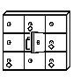 Food Locker
December 2 (Tuesday)  Food Locker  Slots (16 available/week)  Open at midnight on Fri morning for following week  Closes on Sunday. @ 5pm  (Order On-Line Only) | December 4 (Thursday)  Food Locker  Slots (16 available/week)  Open at midnight on Fri morning for following week  Close on Tuesday. @ 5pm  (Order On-Line Only) | December 7 (Sunday)  Food Locker  Slots (16 available/week)  Open at midnight on Fri morning for following week  Close on Tuesday. @ 5pm  (Order On-Line Only)
December 9 (Tuesday)  Food Locker  Slots (16 available/week)  Open at midnight on Fri morning for following week  Closes on Sunday. @ 5pm  (Order On-Line Only) | December 11 (Thursday)  Food Locker  Slots (16 available/week)  Open at midnight on Fri morning for following week  Close on Tuesday. @ 5pm  (Order On-Line Only) | December 14 (Sunday)  Food Locker  Slots (16 available/week)  Open at midnight on Fri morning for following week  Close on Tuesday. @ 5pm  (Order On-Line Only)
December 16 (Tuesday)  Food Locker  Slots (16 available/week)  Open at midnight on Fri morning for following week  Closes on Sunday. @ 5pm  (Order On-Line Only) | December 18 (Thursday)  Food Locker  Slots (16 available/week)  Open at midnight on Fri morning for following week  Close on Tuesday. @ 5pm  (Order On-Line Only)
This institution is an equal opportunity provider.

Visit www.theSHFB.org/programs

December 2025 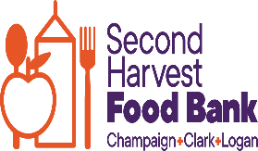
SHFB On-Site Direct Service Schedule
CLARK COUNTY
SHFB On-Site Direct Services SCHEDULE
December 3 (Wednesday)  Order Ahead  Slots (90 available/week) open at midnight on Friday  Morning for the following week  (Order On-Line Only) | December 10 (Wednesday)  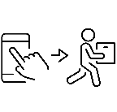Order Ahead  Order Ahead  Slots (90 available/week) open at midnight on Friday  Morning for the following week  (Order On-Line Only)
December 17 (Wednesday)
Order Ahead
Slots (90 available/week) open at midnight on Friday
Morning for the following week
(Order On-Line Only)

Visit www.theSHFB.org/programs

